

#### HUMAN BIOLOGICAL SCIENCES STAGE 2

## **CIRCULATORY SYSTEM**

**EXTENDED RESPONSE**

Name: ___________________________________

**Circulatory System Extended Response**

1. The diagram below schematically represents the blood flow into and out of the heart.

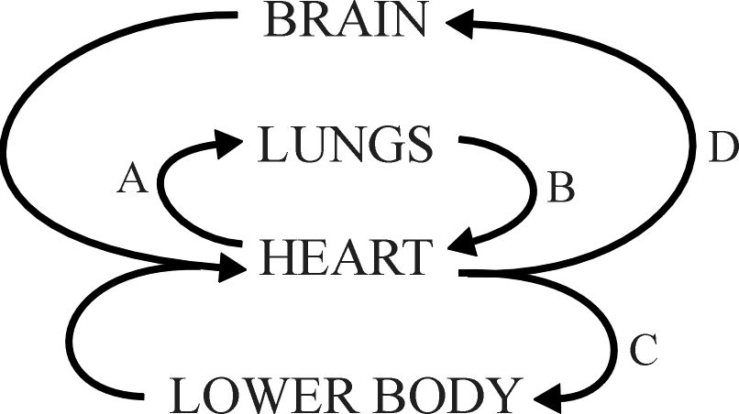

1. Blood taken from which part of the circulatory system (A, B, C of D) would have the highest concentration of oxygen. [1]
2. Name blood vessel A. [1]
3. To which chamber of the heart is blood vessel B connected? [1]
4. Name the major blood vessel from which C and D branch. [1]
5. Veins have a much lower blood pressure than arteries. Discuss the mechanisms that enable veins to return blood to the heart despite this relatively low blood pressure. [2]
6. Electrocardiograms can be used to measure heart rate and analyse the functioning of the heart.
   1. There are three main parts to an ECG – P-wave, QRS complex and T-wave. Label these parts on the ECG below. [1]

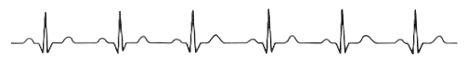

* 1. What is happening in the heart when each of these waves is formed? [3]
  2. Why is the P wave so much smaller than the QRS complex? [1]
  3. If the ECG trace above was taken over a period of 5 seconds, what was the person’s heart rate? [1]

1. Blood pressure in arteries is measured using an instrument called a sphygmomanometer. Explain in detail how you would use this instrument to measure blood pressure. Your answer should include information on the meaning of systolic and diastolic pressure. [5]
2. Consider the following graph:

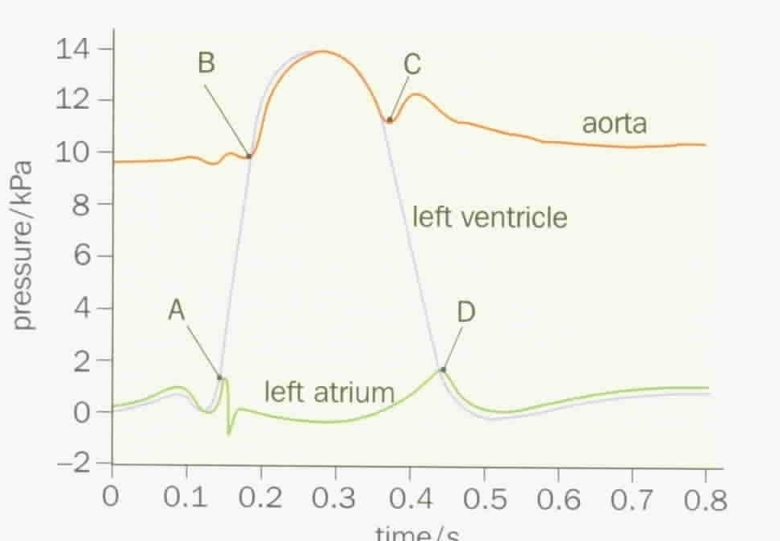

* 1. At point A the pressure in the left ventricle starts to exceed the pressure of the left atrium. What effect would this have on the left atrioventricular valve? [1]

* 1. At point B the pressure of the left ventricle starts to exceed the pressure of the aorta. What effect would this have on the aortic valve? [1]

6. Below is an image of a blood smear taken through a light microscope.

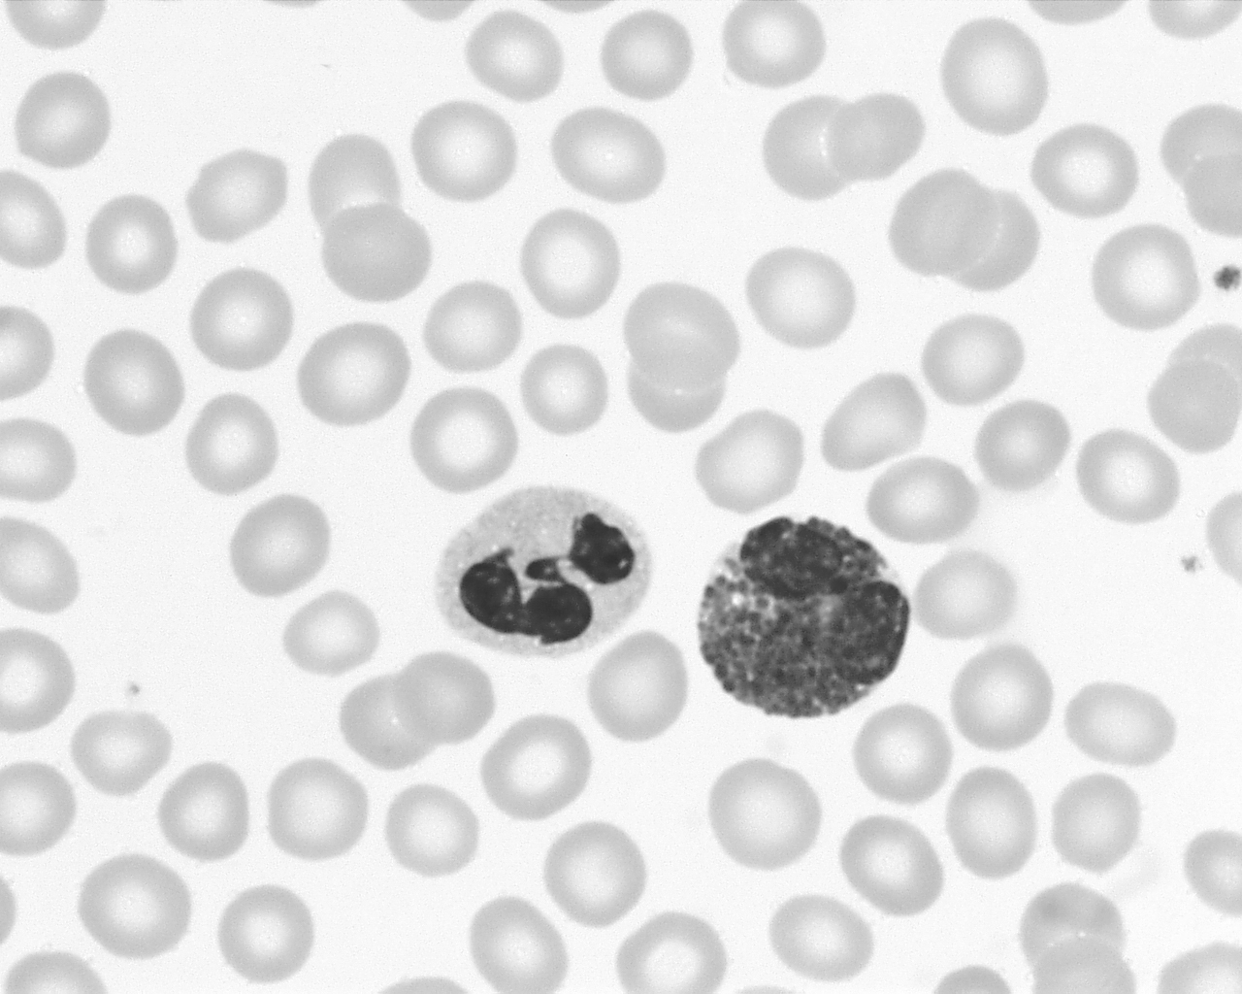

The cell identified by the arrow is a white blood cell.

1. Give two structural features of this cell that distinguish it from the red blood cells. [2]
2. Platelets are not easily identified in this image. Describe the function of platelets? [1]

**END of ASSESSMENT**